Game Validation Setup

Install My Eclipse 6.0.1 (http://www.myeclipseide.com/Downloads-index-req-getit-lid-95.html)

Install the subclipse plugin (http://subclipse.tigris.org/update_1.2.x)
Install Turtoise SNN (http://downloads.sourceforge.net/tortoisesvn/TortoiseSVN-1.4.8.12137-win32-svn-1.4.6.msi?download)

See, detailed steps for installation in “Project setup on Developer Instance.doc”.

- Create a new project using the type SVN->Checkout Projects from SVN
NEW URL - https://svn-tor-01.intertaintech.com/svn/WorldGaming/G4GWebApp/trunk/GameValidation
UserName - Skype ID
Password - Same as Bugzilla
Please follow the following steps to deploy Game Validation.
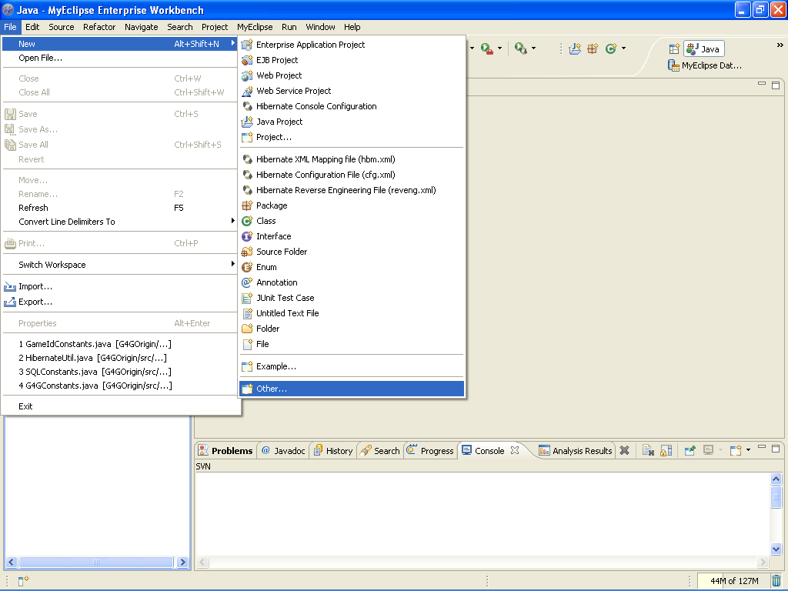

- Select the New -> Other to check out source from SVN.

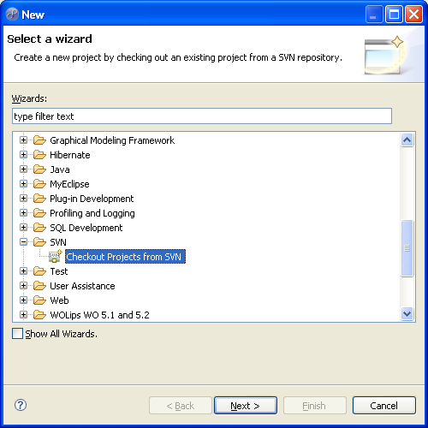

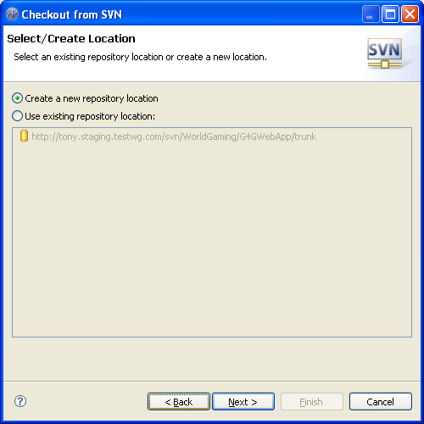

http://tony.staging.testwg.com/svn/WorldGaming/G4GWebApp/trunk/GameValidation

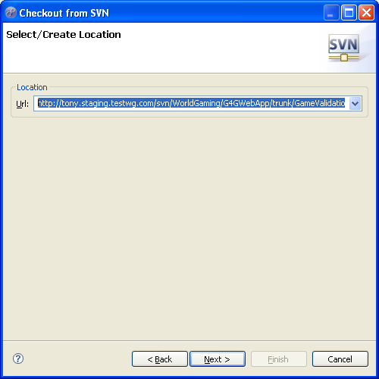

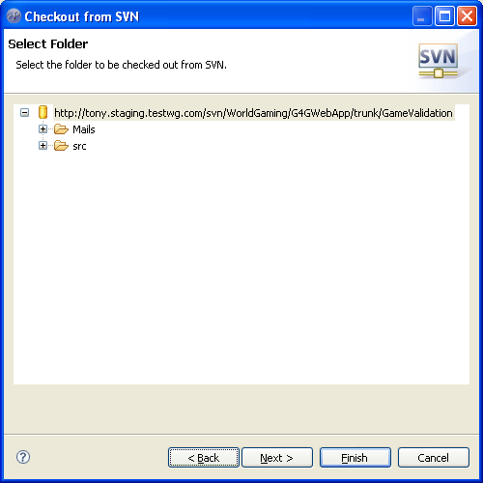

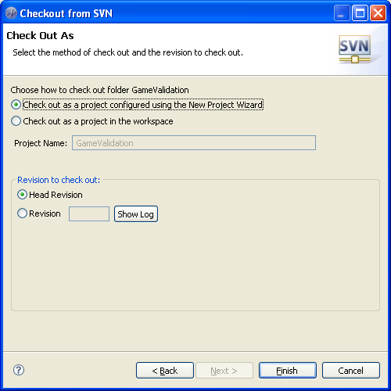

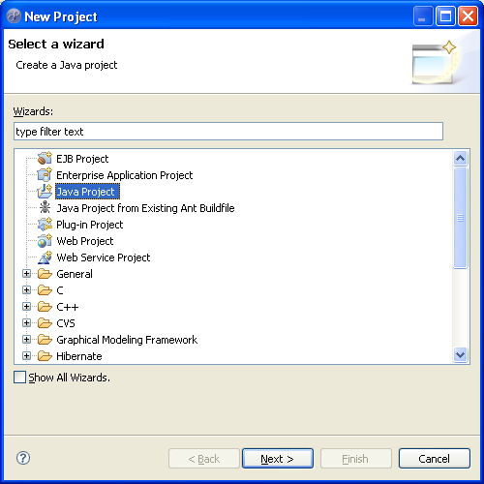

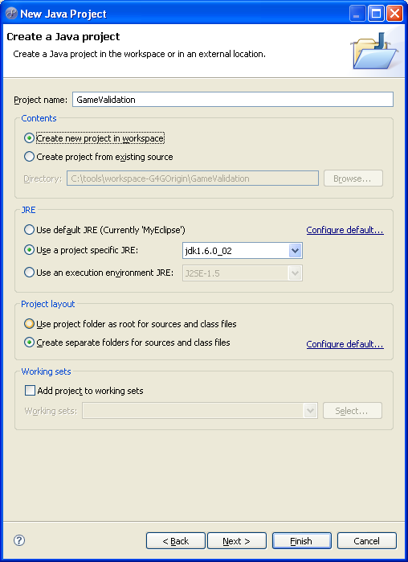

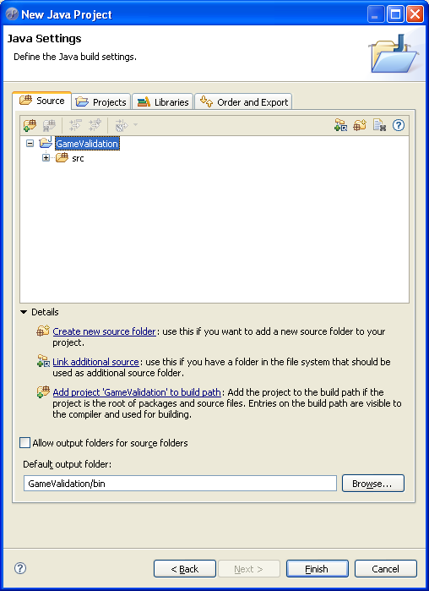

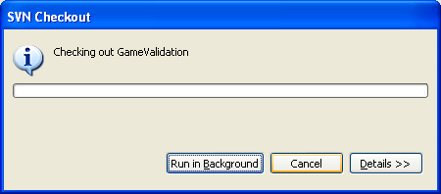

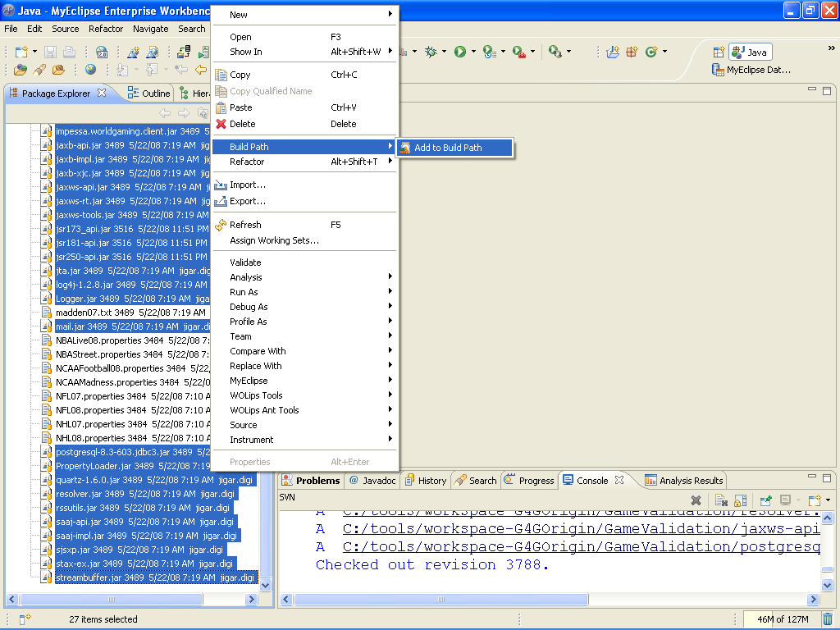

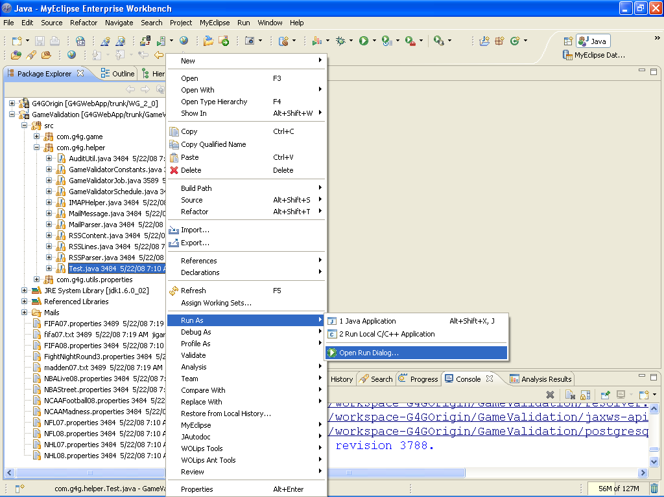

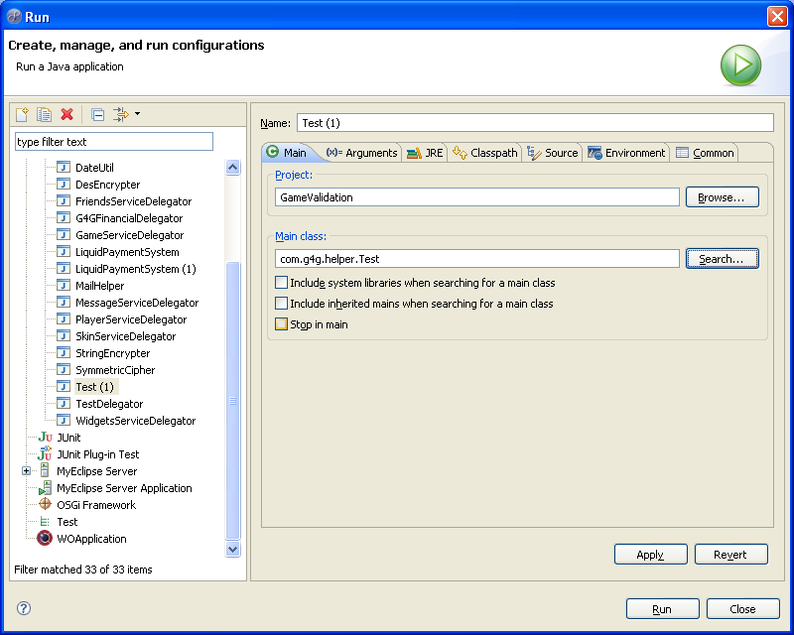

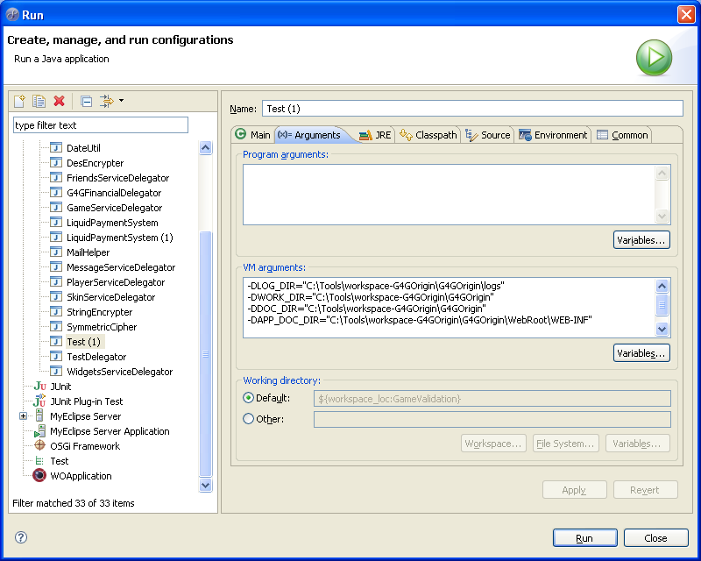

To test the Game Validation through Eclipse IDE, you need to set the following parameter under VM arguments for com/g4g/helper/Test.java.

-DLOG_DIR="C:\Tools\workspace-G4GOrigin\G4GOrigin\logs"
-DWORK_DIR="C:\Tools\workspace-G4GOrigin\G4GOrigin"
-DDOC_DIR="C:\Tools\workspace-G4GOrigin\G4GOrigin"
-DAPP_DOC_DIR="C:\Tools\workspace-G4GOrigin\G4GOrigin\WebRoot\WEB-INF"
-DSERVER_INSTANCE=SANDBOX

After setting up the above arguments click on Run followed by Apply.

